FOURTH INTERNATIONAL CONFERENCE ON INTELLIGENT

COMPUTING

**IOT BASED SAFETY KIT FORCONSTRUCTION WORKERS**

**Jenifer.S**  **Sudharshna.U**

jensutha99@gmail.com sudharshnakumar@gmail.com

**Sameera.H** **Mrs.R.Devi**

samee2400@gmail.com Assistant professor(Grade 1)

deviramakrishnanpec@gmail.com

Department of Computer Science and Engineering,

Panimalar Engineering College, Tamil Nadu, India.

**Abstract:**

The Indian Institute of Technology (IIT) conducted a survey and found out that about 48,000 workers die every year in the due to accidents which occur in their occupation, that is approximately equal to around 38 workers losing their lives every day, and 38 families losing the sole bread earner of their families. India has a total population of 138 crore and a total workforce of 46.5 crore, so a sum of approximately 46 crore people are in a need of a solution to this grave danger which they face every day. There are no products designed at present to help reduce the number of deaths in the construction field, so our product will be one in a kind. A handy IOT based safety kit is designed for the construction workers. Each kit has a unique ID, and is to be worn at all times by the workers, when they are on – site. If an accident occurs on the site causing the user to get stuck between a mass of debris, this kit will be instrumental in the rescue process.

**I Introduction:**

Internet of things is a set of connections of many sensors and modules. In our proposed product, this network of things help the supervisors in the construction field in daily life and especially during rescue missions if any untoward accident occurs to the construction workers, on the site.

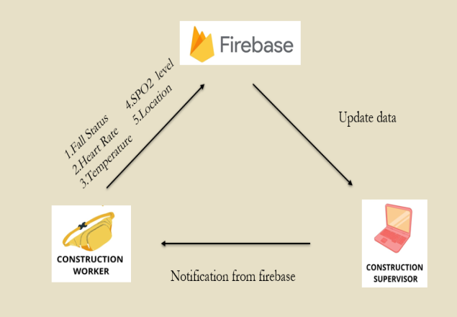

A research paper “An estimate of fatal accidents in Indian construction” by Dilip kumar Patel and Kumar Neeraj Jha reports that every year 24.20% of the deaths occurring at occupational sites are caused by the construction industry, causing it to be the highest in the nation every year. It is also reported that about 80% of the construction sites in India are unsafe. The British Safety Council, an organization committed to safety at the place of work, has declared officially that there is only one overseer for every 500 factories.

This shows that, some sort of protective measures need to be taken by the construction workers while working in the site. If the workers wear our device while working everyday, it will be useful in the longer run, and a peace of mind can be achieved in the knowledge that if anything goes wrong, quick measures can be taken during the rescue process.

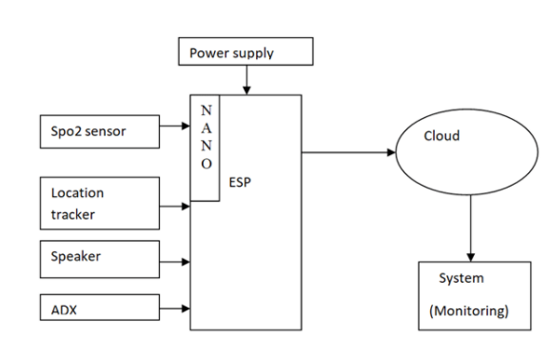**II Literature Survey**

1.Pulishetty Prasad et all proposed a system “Zigbee Based Intelligent Helmet For Coal Miners” in 2017. It discovers real time monitoring with timely warning intelligence when there is a leakage of gas, rise or drop in temperature and informs control station by using new age Zigbee wireless technology. This system helps in pointing the location of a person accurately and covers a massive area. The major disadvantage of this system is that it is particularly focused on workplace safety rather on workers.

2.Mangala Nandhini. V et all proposed a system "IOT based Smart Helmet for Ensuring Safety in Industries" in 2018.This system provides actual timedetection of threatening gases like  CO,CH4, LPG , temperature and humidity and provides emergency alert to the control station. Wi-Fi is used to transfer data from the helmet to the monitoring station. The reliability and durability of the communication system is poor.

3.Raghavendra Rao B et all proposed a system "‘SIRASTRANA’: A Smart Helmet for Air Quality and Hazardous Event Detection for the Mining Industry "in 2018.In the event of miners struck by a hard rock or any object on their heads with a force over a stated limit of 1000 on the HIC (Head Injury Criteria) the accelerometer alerts the monitoring station.Helmet Removal Sensor it alerts when the worker has removed the helmet during working hours. But this system does not provide any other protective measures in case of emergency conditions.

4. K.Divya et all proposed a system "A Smart Helmet For Improving Safety In Mining Industry" in 2017.In case of any poisonous gas detection the helmet provides oxygen by opening a valve. It detects hazardous event, monitors and provides oxygen supplements to avoid the inhalation of poisonous gases. The helmet is too heavy since it contains oxygen cylinders which is uncomfortable to work with.

5.C.Jagadeeswari et all proposed a system "Hard Hat Detection Using Deep Learning Techniques" in 2020.This system uses YOLO algorithm – a much faster algorithm in object identification to detect whether the worker is wearing the helmet during working or not. The main advantage of this system is that it protects the head which is the most crucial part of the body.But this system has a clear motive to protect only the head and does not provide any other support during emergency situation.

6. Jie Luo et all proposed a system "Highly Portable, Sensor-Based System for Human Fall Monitoring" in 2017.This system consists of a highly portable sensor unit including a triaxis accelerometer, a triaxis magnetometer, and a mobile phone and with the data from these sensors, systemobtains the acceleration and Euler angle (yaw, pitch, and roll), which represents the orientation of the user’s body. This system helps in fall detection and help in daily life of elders. It focuses onproviding safety for elderly people but not for the industrial workers.

**III Proposed System:**

Our proposed system is a small kit which comprises of the following components SPO2 sensor, ESP8266 board, location tracker (bluetooth), speaker, ADX–average directional index (sensor-MPU6050), LM35 (temperature) and Google firebase is used as the cloud platform. There are five different modules present in our product are

1. Fall Detection Module,
2. Temperature Sensing Module,
3. Oxygen Level Sensing Module,
4. Location and Position Sensing

Module

1. Heart Rate Detection Module.

**Fall detection module:**

This module consists of a tiny self-assembled sensor unit which is used to calculate the angular velocity of an object and the human body’s motion or acceleration. A single chip has both an accelerometer and a gyroscope embedded into it. This chip is then fixed inside the kit. It detects the axis, gravity and acceleration. They aid us in detecting falls caused due to fatigue, drowsiness, etc. The APP uses the axis to detect if a fall has taken place, by using the fall detection algorithm. As soon as a fall is detected, the contractor is notified. For our system the power supply is provided by connecting the kit to the laptop but we can attach a battery with 3.5 -5 volts in future, ensuring that it will be easy for the users to carry it around.

**Temperature sensing module:**

The temperature sensor senses the temperature of the construction worker who is wearing the device. The threshold value for this temperature sensor is 80. It helps in determining if a construction worker is sick or not.

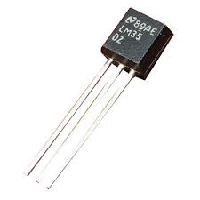

**Oxygen Level Sensing Module:**

This module will be used to measure if the respiratory systems are working or not. It measures the amount of oxygen present in the blood of a worker, and so will be useful in finding the worker is alive and healthy after an untoward accident takes place.

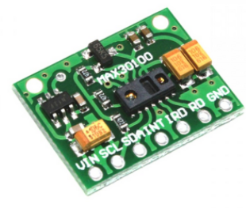

**Location and Position Sensing Module:**

Location sensor to find out the location of a particular worker is present using unique ID, Eg: Worker ID 8266 is in 1st floor. It also help to check in groups - The number of people working at a particular floor at a particular time. Position sensor will be useful to determine the number of people who are stuck in event of accident.

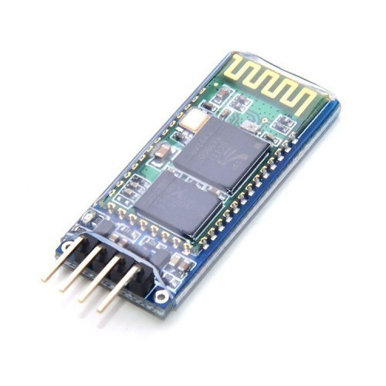

**Heart Rate Detection Module:**

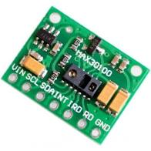

This sensor is used to find out the rate of heartbeat of a particular user (Construction Worker). In a event of disaster this sensor is used to determine whether the worker is still alive or not to proceed with evacuation.

**SPO2 sensor**

The LED’s present in this sensor, shines the light through the tissues, and the sensor present on the other side, finds out the amount of light which is transferred through the tissues to find out the amount of oxygen present in the blood stream.

Let us see in detail about the different components used in this kit,

**ESP8266 board**

This device  is an economical Wi-Fi microchip, with a full TCP/IP stack and microcontroller ability. It allows microcontrollers to link to a Wi-Fi web and make simple TCP/IP  interconnections making use of  Hayes-style commands.

**Location tracker (Bluetooth):**

Location tracker receives the location based on the Bluetooth module which will be placed at each and every floor. Using this the location of each and every person can easily be located by the building’s supervisor.

**Speaker:**

A speaker is an electroacoustic transducer. This device changes an electrical audio signal into the corresponding sound.

**ADX –average directional index (sensor-MPU6050):**

The MPU6050 is a Micro Electro-Mechanical Systems (MEMS). It contains a 3-axis Accelerometer and a 3-axis Gyroscope inside it.This assists to calculate acceleration, velocity, orientation, displacement and many other motion allied parameter of a system or object.

**LM35 (temperature):**

LM35 is a temperature sensor that outputs an analog signal which is corresponding to the prompt temperature. The output voltage can easily be explained to obtain a temperature reading in Celsius. The lead of lm35 over thermistor is it does not need any external calibration.

**Google firebase:**

Firebase is the Google's mobile application development platform and  helps you set up better, and expand your app.

**Experimental result:**

The output of this experiment is, that it is a system which can be worn easily by the construction workers in theirs hands while carrying out their job. It finds out if the person in question is standing straight or if he has fallen down, their heartbeat rate, and the status of their heartbeat, their location, the amount of oxygen in their blood, their body temperature and the status of their body’s temperature, and sends the result to the building supervisor’s system.

**Output Image:**

**Hardware:**

A kit enclosed in a plastic box and worn on the wrist of the construction worker is as shown in the image below.

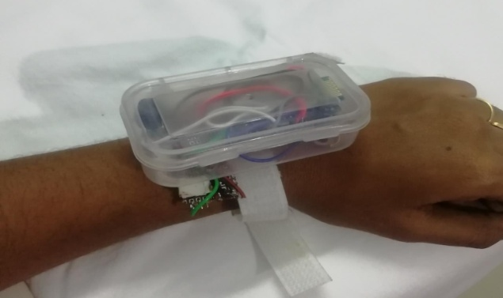

**Software:**

The data output as shown for each person in the supervisor’s system is shown in the image below.

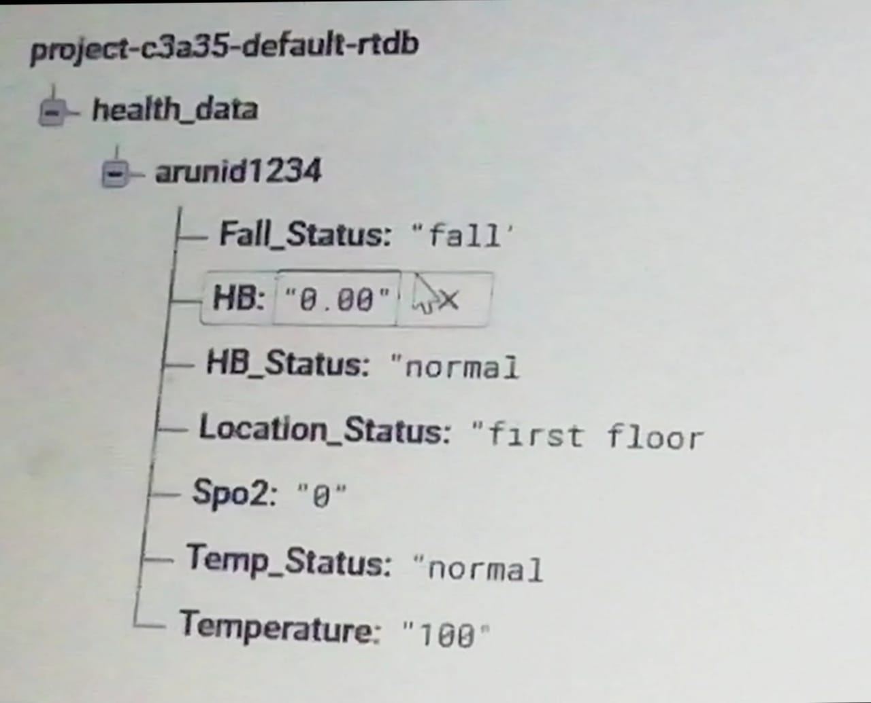

**Reference:**

1.     A Smart Helmet For Improving Safety In Mining Industry by Mrs.A.Dhanalakshmi P.Lathapriya, K.Divya.

2.      Automatic Fall Detection using Smartphone Acceleration Sensor by Tran Tri Dang, Hai Truong, Tran Khanh Dang.

3.      Fall Detection Based on Accelerometer and Gyroscope using Back Propagation by Adlian Jefiza1 , Eko Pramunanto  , Hanny Boedinoegroho , Mauridhy Heri Purnomo.

4.      Hard Hat Detection Using Deep Learning Techniques by C. Jagadeeswari, Nagamani.G, Sneha.B and Dr. G. NagaSatish.

5.      Highly Portable, Sensor-Based System for Human Fall Monitoring by Aihua Mao, Xuedong Ma, Yinan He and Jie Luo.

6.      IoT based Smart Helmet for Ensuring Safety in Industries by Mangala Nandhini. V , Padma Priya G.V , Nandhini. S, Mr. K.Dinesh.

7.      A Smart Helmet for Air Quality and Hazardous Event Detection for the Mining Industry by Raghavendra Rao B,  Karthik NS,  NA Poojitha,  Divya L, Nandini N.

8.      Smart Helmet for Coal Miners using Zigbee Technology  by Shirish Gaidhane , Mahendra Dhame & Prof. Rizwana Qureshi.

9.      Smart Helmet for Coal Mines Safety Monitoring and Alerting by S. R. Deokar , V. M. Kulkarni, J. S. Wakode.

10.    Zigbee based intelligent helmet for coal miners by Pulishetty Prasad , Dr. K. Hemachandran , H.Raghupathi.

11.    [British Safety Council opens office in India to help save lives | British Safety Council (britsafe.org)](https://www.britsafe.org/about-us/press-releases/2017/british-safety-council-opens-office-in-india-to-help-save-lives/)

12.    [British Safety Council establishes a ground-breaking forum in India for sharing best practice in health, safety and wellbeing | British Safety Council (britsafe.org)](https://www.britsafe.org/about-us/press-releases/2018/british-safety-council-establishes-a-ground-breaking-forum-in-india-for-sharing-best-practice-in-health-safety-and-wellbeing/)